OVERALL PROGRAMME EVALUATION REPORT
Social Entrepreneurship Development Program (SEDP)- Advance Tanzania (2nd February - 6th February 2026)
No. of Respondents: 23
No. of Participants: 300
Response Rate: 8%
--------------------------------------------------

Faculty Reports

Tim Kipchumba - Establishing Social Impact/ Measuring Social Impact
Evaluation Parameter | (%) Individual Score | (%) Programme Average
Punctuality (Commencement and Completion of Sessions) | 98 | 95
How well do you understand the core concepts presented? | 86 | 90
Rate your confidence in applying the new skills learnt | 89 | 91
Degree of Faculty preparedness for the sessions | 95 | 94
Content and methodology of the program | 97 | 94
Quality of class and group discussions | 94 | 92
The information presented in the course is relevant to my work (ministry) | 94 | 94
Average scores | 93 | 93

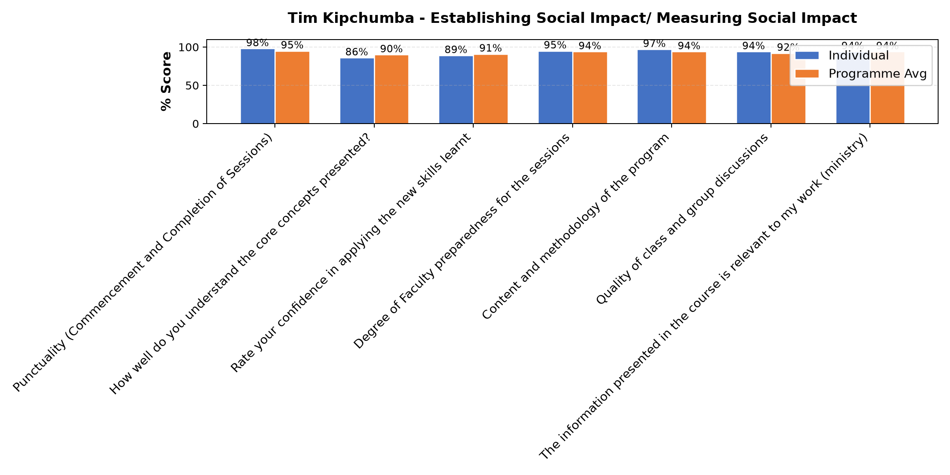

Comments & Feedback
- • Namna ya kuendesha biashara Kwa ufanisi.
- • Protocols
- • Ni Mwalimu bora.
- • Ana uzoefu mzuri.

Tim Kipchumba - Funding Sources
Evaluation Parameter | (%) Individual Score | (%) Programme Average
Punctuality (Commencement and Completion of Sessions) | 97 | 95
How well do you understand the core concepts presented? | 92 | 90
Rate your confidence in applying the new skills learnt | 97 | 91
Degree of Faculty preparedness for the sessions | 95 | 94
Content and methodology of the program | 95 | 94
Quality of class and group discussions | 95 | 92
The information presented in the course is relevant to my work (ministry) | 95 | 94
Average scores | 95 | 93

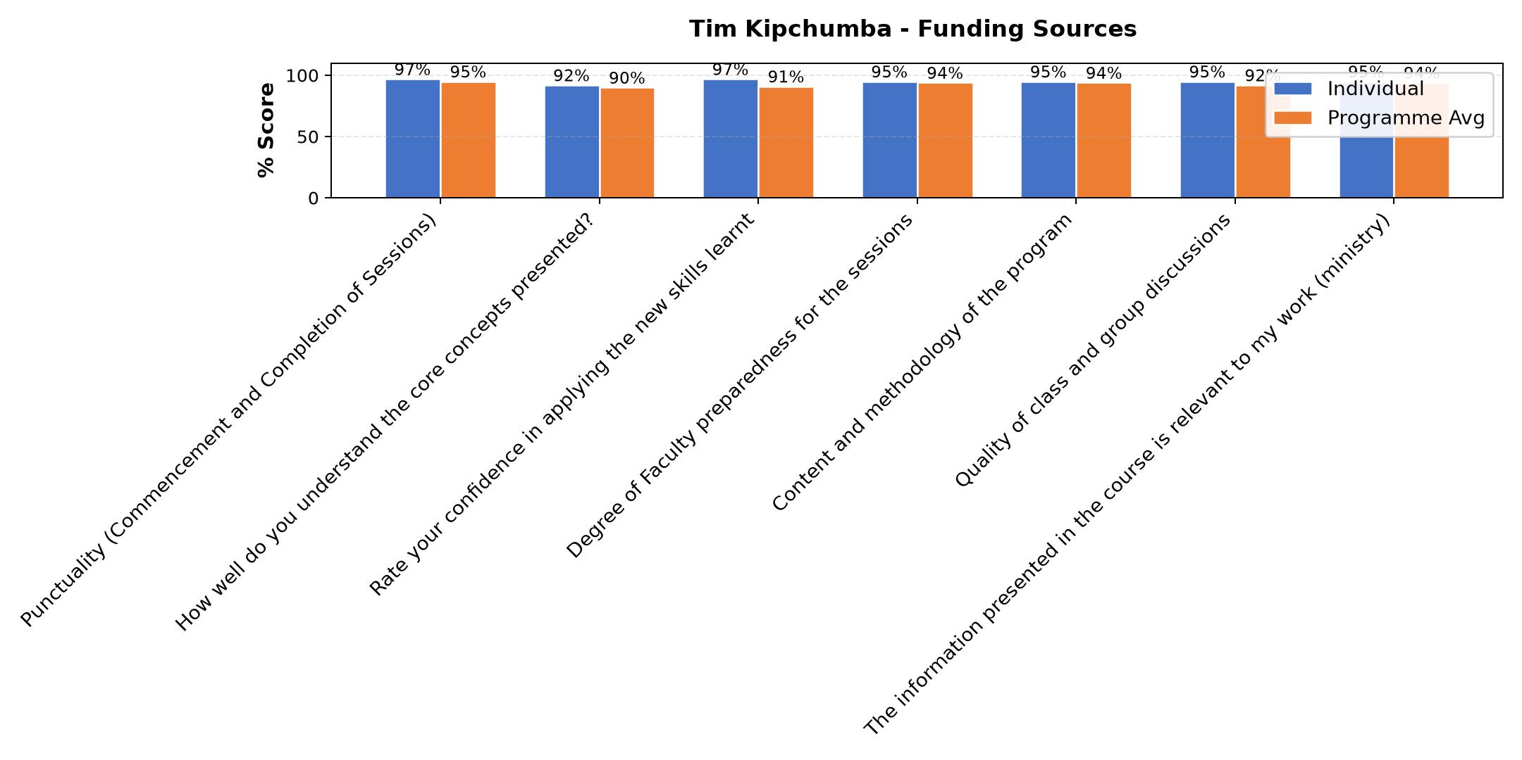

Comments & Feedback
- • I don't have donor addresses
- • Nil
- • It might be lacking the commitment to work on this given task
- • Thanks
- • Somo limefundishwa vizuri
- • Ana uzoefu mzuri .
- • Amewasilisha kwa kiwango halisi.
- • Amefundisha vizuri sana
- • How to write project and to meet the funding sources
- • Nimejifunza mambo yafutayo.
Vyanzo vya ufadhili.
b.sababu za kutafuta ufadhili.
C.tunawezaje kuimarisha uaminifu wetu.
D.uahitaji fedha kiasi gani?.
E.wawejezaji wanataka nini.
F.wawekezaji hataki nini.
Ninatakiwa niwe na hoja yenye mvuto na inayoshawishi.
- • No barriers

Dr. Freshia Wangari Mugo-Waweru - Governance and succession planning
Evaluation Parameter | (%) Individual Score | (%) Programme Average
Punctuality (Commencement and Completion of Sessions) | 96 | 95
How well do you understand the core concepts presented? | 98 | 90
Rate your confidence in applying the new skills learnt | 95 | 91
Degree of Faculty preparedness for the sessions | 98 | 94
Content and methodology of the program | 98 | 94
Quality of class and group discussions | 100 | 92
The information presented in the course is relevant to my work (ministry) | 99 | 94
Average scores | 98 | 93

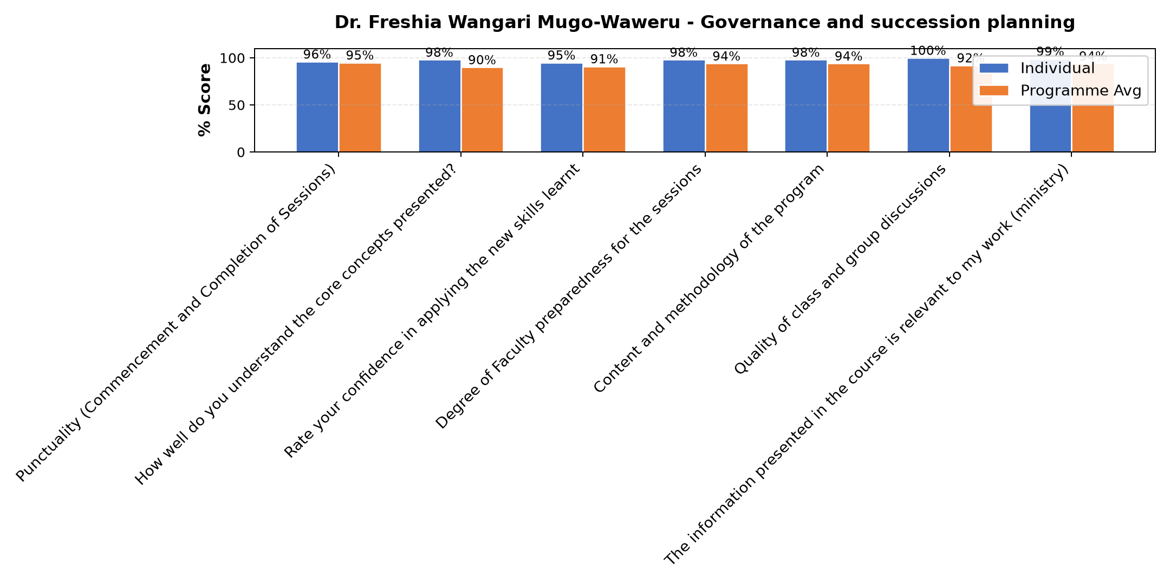

Comments & Feedback
- • Ni mwalimu mzuri sana
- • Mbunifu anawapa wanafunzi motisha.
- • Mwalimu ameeleweka vizuri sanaa
- • Nimejifunza mambo yafutayo.
- • a.mwelekeo wakimkakati
- • b.rasimali inatakiwa iweje.
- • c.usimamizi na uangalizi.
- • d.majukumu ya bodi kwa ufanisi.
- • e.majukumu na wajibu.
- • Nothing,
- • May be lacking commitments
- • No burriers
- • Namna ya kuwa kiongozi Bora
- • Excellent
- • Ni kubadili mitazamo ya wale walionitangulia na wenye uzoefu wa kazi kuhusu kubadili baadhi ya sehemu ambazo nimejifunza kwa ajili ya kuboresha taasisi zetu
- • Nil
- • Nothing
- • Kikwazo vinavyoweza kujizuia kutumia vizuri elimu hiyo miliyofundiswa. Kuna ushindani wa ile biashara yangu. Matumizi sahihi ya IT ukosefu wa vifaa vya kisasa kuendana mabadiliko ya ulimwengu wa sayansi na teknologia n.k
- • Only lacking commitment

Kenneth Wakati - IT and Technology
Evaluation Parameter | (%) Individual Score | (%) Programme Average
Punctuality (Commencement and Completion of Sessions) | 92 | 95
How well do you understand the core concepts presented? | 82 | 90
Rate your confidence in applying the new skills learnt | 82 | 91
Degree of Faculty preparedness for the sessions | 87 | 94
Content and methodology of the program | 86 | 94
Quality of class and group discussions | 81 | 92
The information presented in the course is relevant to my work (ministry) | 87 | 94
Average scores | 85 | 93

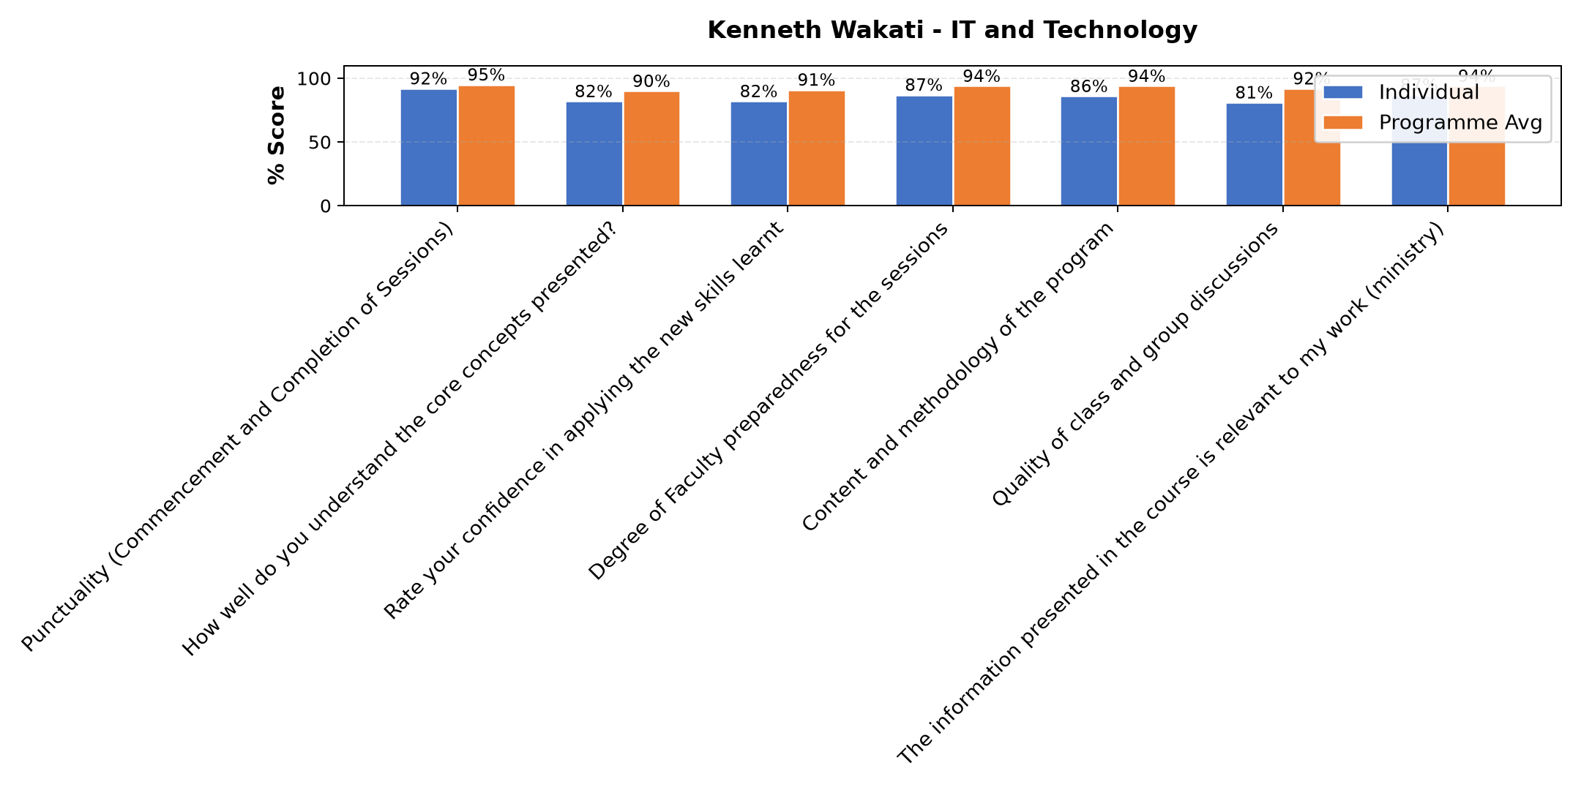

Comments & Feedback
- • Nimejifunza namna ya kutumia mtando na namna yakutangaza biashara yangu kwenye mtandao,pia ninavyo ingia kwenye mtando niwe makini na siyo kuogopa .
- • Not having modern tools like computer, phones, tablets etc
- • Lack of opportunities to apply the learning in real situation
- • Nothing
- • Ana uzofu wa kuwasilisha mada/ujumbe, somo lake lilieleweka kwa asilimia kubwa sana Wanafunzi waliweza kuingia kwa undani kwa njia ya kuuliza maswali.
- • Mwl amefundisha vyema kabisa
- • Nil
- • Just a phobia that am not safe
- • Ufahamu si mpana kwa baadhi ya program na matumizi yake
- • How to protect my ministry by creating strong password and verify information.
- • It might be indicators for technology hakers on that moment
- • Lack of enough knowledge about IT and new Technologies

Dr. Diana Kageha Ominde - Operations and Efficiency
Evaluation Parameter | (%) Individual Score | (%) Programme Average
Punctuality (Commencement and Completion of Sessions) | 93 | 95
How well do you understand the core concepts presented? | 90 | 90
Rate your confidence in applying the new skills learnt | 90 | 91
Degree of Faculty preparedness for the sessions | 93 | 94
Content and methodology of the program | 93 | 94
Quality of class and group discussions | 90 | 92
The information presented in the course is relevant to my work (ministry) | 94 | 94
Average scores | 92 | 93

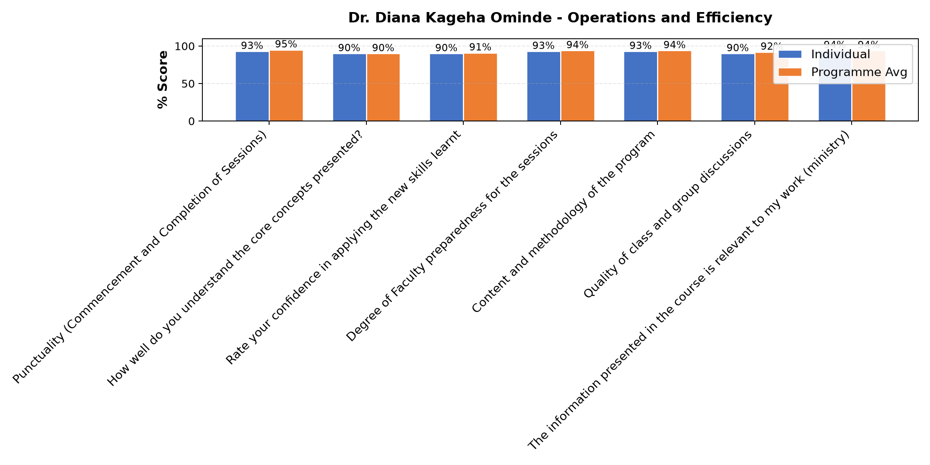

Comments & Feedback
- • Kufanya kaxi na watu tunaotofautiana malengo.
- • Mwl amefundisha vizuri
- • Team effectiveness
- • Amejitahidisana.
- • Ametumia uzoefu kadiri ya uwezo wake
- • Amewapa chemsha ubongo wanafunzi na kutoa motisha.
- • Nimejifunza ,kwamba ,hatua za kimkakati,kuimarisha mifumo ya uendeshaji,
- • Kutambua mambo yanayopunguza ufanisi
- • .kuweka majukumu wazi
- • .upimaji na utendaji
- • Non
- • Sina kipingamizi chochote, nitajitaji kufanyia kazi ujuzi wote ulionipa asante
- • Mostly to work with lay people in our institution without our fellow sisters
- • Understood by me.
- • No barrier can prevent me to implement
- • Lack of personal and enough money

Department Reports

Overall Evaluation
Evaluation Parameter | (%) Score
Overall program evaluation | 98
Average score | 98

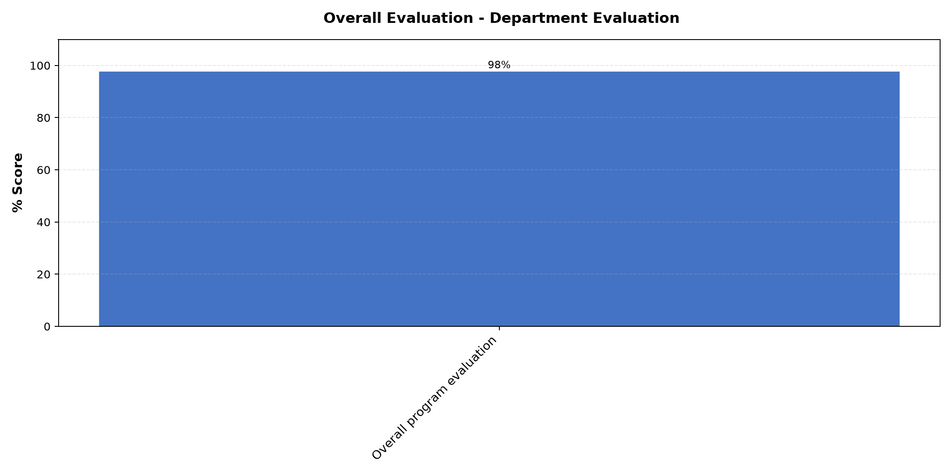

Comments & Feedback
No comments recorded.

Accommodation Venue
Evaluation Parameter | (%) Score
Comfort and cleanliness of the accomodation | 89
Quality of meals and dining services provided | 89
Overall satisfaction with the accomodation experience | 91
Average score | 90

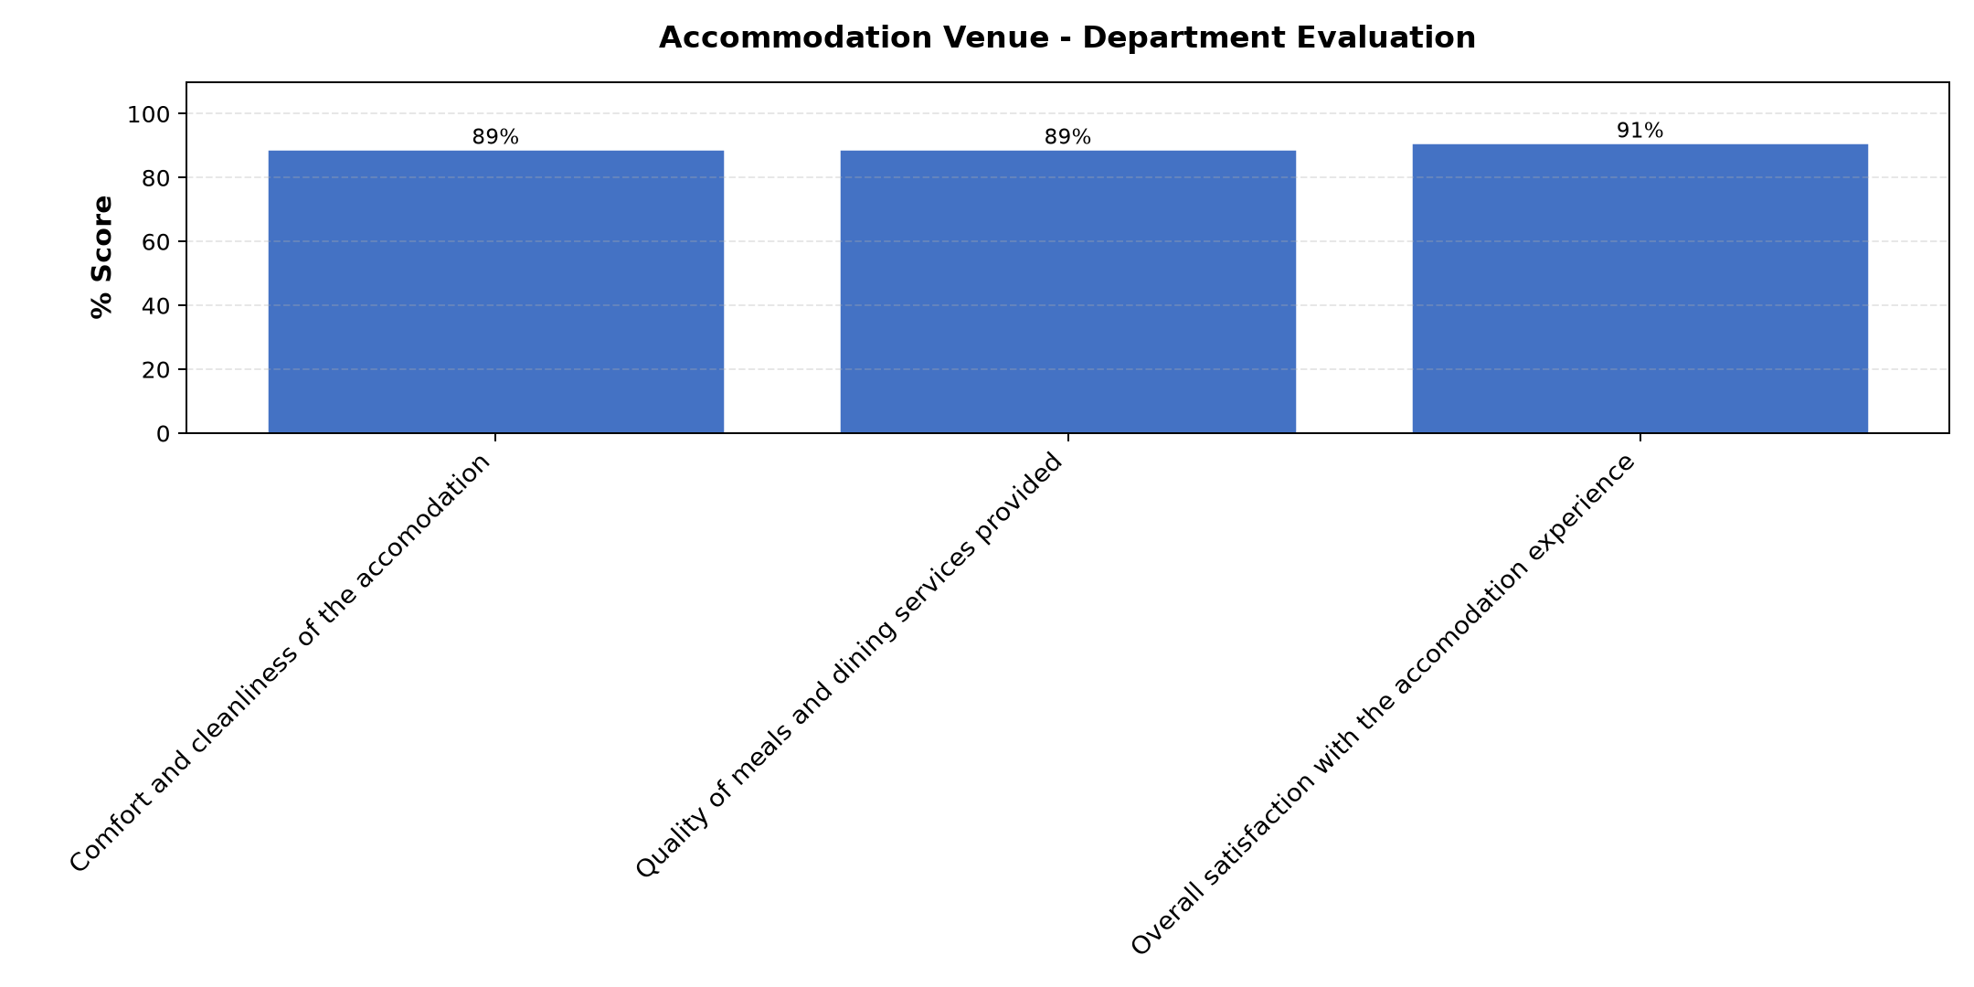

Comments & Feedback
- • Thanks
- • Iko vizuri
- • Ninzuri
- • Well served and on time
- • May the God. Strengthen them now and then
- • Thanks
- • Mungu awabariki sana wahudumu Kwa huduna zenu nzuri.
- • The electric of the bathroom is not working. So more investigation is required before hosting a person.
- • To look for good place for meeting like this one
- • Well prepared

Are there any other comments and/or suggestions that you may want to add?

Comments & Feedback
- • Nashukuru sana kwa mafunzo haya naahidi kutekeleza
- • Nawashukuru sana kwa haya mafunzo nahidi kuyafanya kazi.
- • Thanks again to Strathmore teams members for conducting this program to us. Thanks.
- • Thank you very much
- • I congratulate all program supervisor
- • Ninawashukuru Kwa Kila jambo Mungu awabariki nyote
- • Kindly not clean our rooms every day at least after 3 to 4 days
- • To have enough time at least two days for each teacher
- • Cha kwanza ni shukurani kwa timu nzima iliyotupayia mafunzo haya. Tunaomba kama kuna uwezekano wa kuyapata tena kama kikundi baada ya miaka kama mitatu hivi. Pia kututembelea
- • Only blessing

Day 1 Comments

Comments & Feedback
- • Mungu akubariki sana ninashukuru kwa kutoa muda wako kutuelimisha,nitayafanyia kazi
- • Our teacher tried his level best. As students we need more class practice because IT is not easy especially for some of us who are advanced in ages. Thanks
- • To day teacher is good
- • Good topic
- • Nampa hongereni sana.
- • Somo limeeleweka vizuri tunaahidi tutakwenda kulifanyia kazi
- • The lesson was well understood.
- • No comment
- • Kujitahidi kuenda na wakati
- • To create strong password
- • Well conducted
- • Pengine kungekuwa na mda wa mazoezi kwa vitu vingine bila kusubiri wanafunzi kuomba msaada wa profesor. Hii ingesaidia participation zaidi
- • Thank you for your presentation
- • Thank you very much for this IT and Technology knowledge to ours particularly to me.Be blessed
- • Thanks

Day 2 Comments

Comments & Feedback
- • Thanks
- • Nampongeza mkufunzi uwasilishaji mada umekidhi matarajio.
- • Somo limeeleweka vizuri
- • Thank you for everything
- • Nampa Hongera sana, aongeze uzoefu
- • Mungu amjalie baraka nyingi na aendlee kuwa na moyo huo huo wakufundisha
- • No skills in running our service or institution
- • Enjoyable lesson.
- • Thanks be blessed

Day 3 Comments

Comments & Feedback
- • To have project which have been funded by more than 1 fund's
- • Nothing
- • The lesson was good well understood.
- • May Might God Bless the facilitator
- • Thanks again
- • Somo limeeleweka na nitalifanyia kazi
- • Hongera sana.
- • Jaribu kutumia lugha ya kiswahili{niwie radhi }
- • Asante sana Kwa mafundisho mazuri.
- • Asante kwa nunielimisha mungu akubariki sana yote niliyojifunza nitayafanyia kazi
- • Good

Day 5 Comments

Comments & Feedback
- • Thanks
- • Nampa hongera sana.
- • Somo limeeleweka vizuri mno mnoooo
- • Nitayafanyia kazi ,aendlee kuwasaidia wengine,tuelimike wengi.
- • Well understood topic.
- • Be blessed Doctor
- • Nashukuru Kwa mashirikisho nzuri.
- • Ningependa program hizo zitolewe zaidi ili masista wengi wapate ujuzi zaidi wa kuendesha taasisi zetu
- • Well taught.

Guest-Speaker Session
Evaluation Parameter | (%) Score
Speaker's Quality of discussions | 85
Speaker's degree of preparation for the session | 89
Information presented in the course was relevant to my work | 86
Presentation was well structured | 85
Delivery methodology was appropriate | 87
Average score | 86

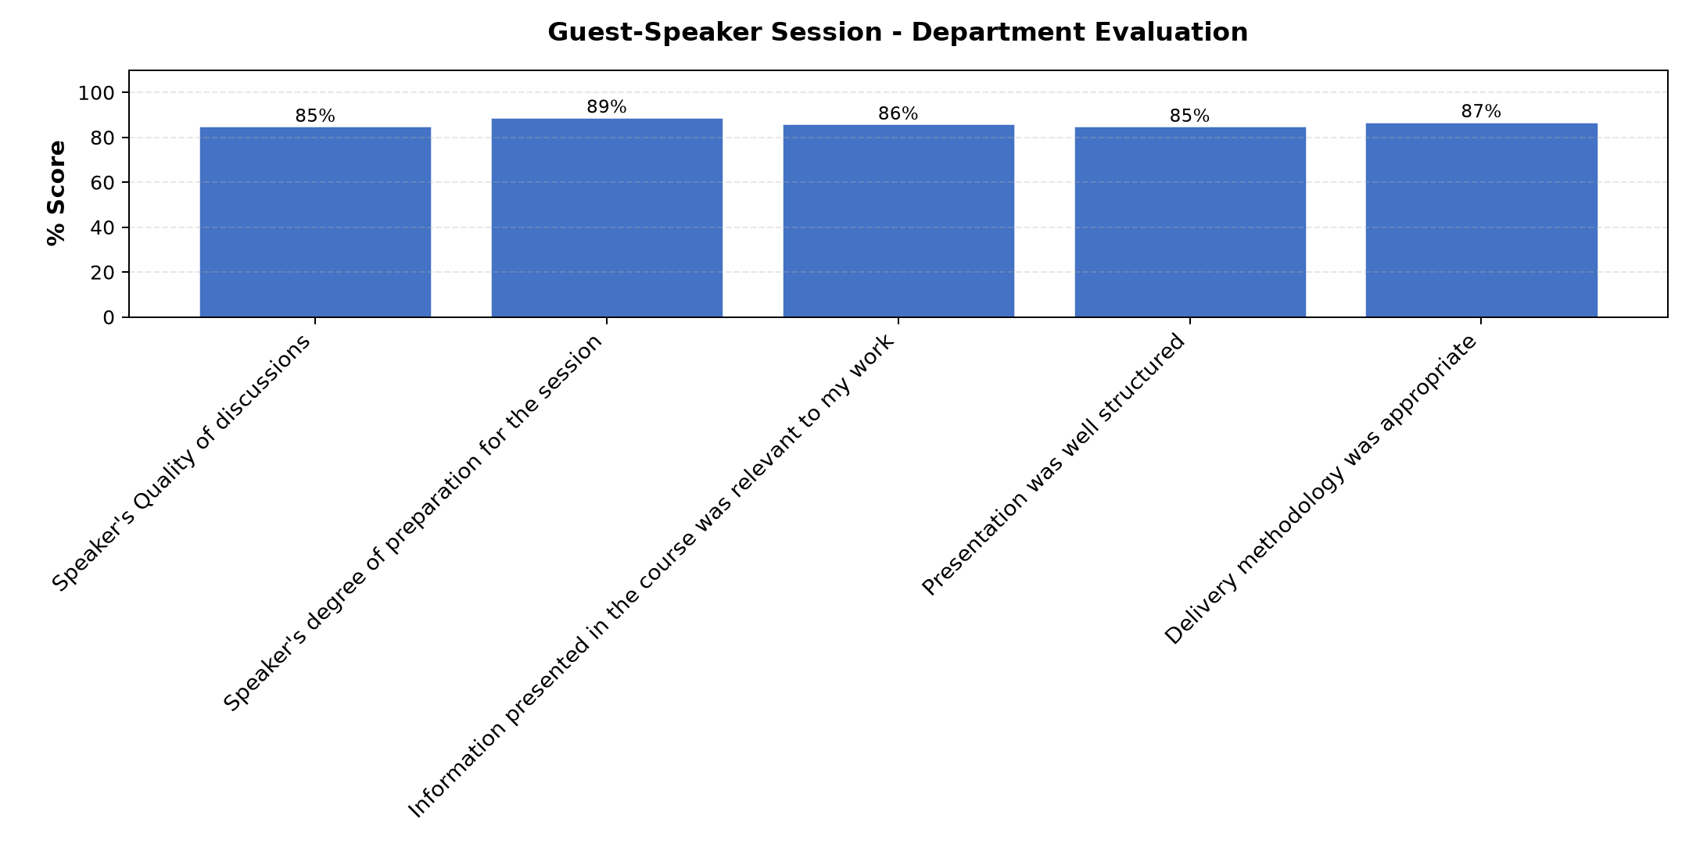

Comments & Feedback
- • Ameeleweka vizuri
- • Nimefurahia masomo niliyopata nitayafanyia kaz.
- • Well done
- • Thanks
- • Thank very much be blessed
- • Good
- • Asante sana.
- • Very good

Program Manager (Venance Mwakangale)
Evaluation Parameter | (%) Score
Punctuality in sending materials and programme information | 98
Communication skills(verbal and written) | 100
Response to programme enquiries via email, whatsapp and calls | 99
Accessibility and willingness to support when needed | 99
Quality of service / professionalism | 96
Average score | 98

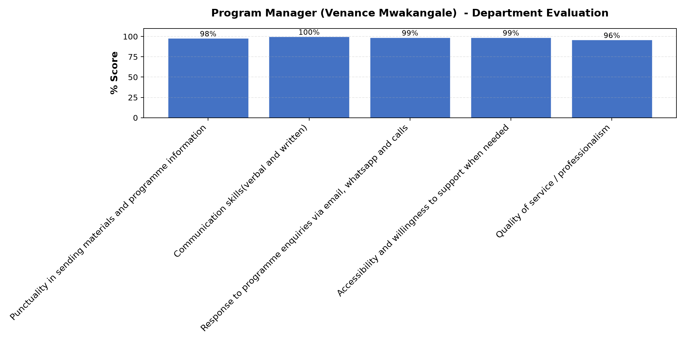

Comments & Feedback
- • Be blessed
- • Excellent
- • Yuko vizuri sana tena sanaaa
- • Ninashukuru sana
- • Congratulations to them
- • Excellent program manager
- • Ninamshukuru sana kaka venance Kwa jinsi Mungu alivyomjalia moyo wa usikivu na uvumilivu ktk kutusaidia sisi Masista.
- • Thanks
- • Well accountable .

Social Enterprise Visit
Evaluation Parameter | (%) Score
Quality of the pre-visit planning & information shared.1 | 98
Quality of the plant visit | 94
Quality of content discussed.1 | 97
Overall company visit evaluation.1 | 97
Average score | 96

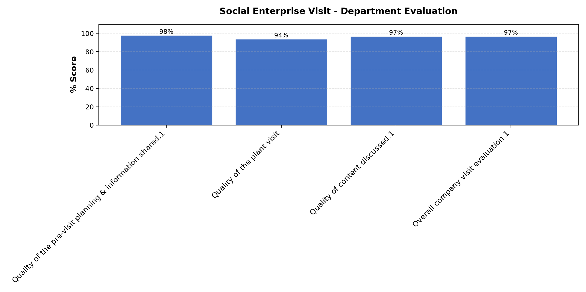

Comments & Feedback
- • Ninashuku Kwa ziara nimejifunza Kwamba Kila kitu kinawezekana ukiweka moyo
- • Tunashukuru sana kwa mafunzo mazuri
- • Very enjoyable
- • Thanks
- • Thanks for all teachers for giving us skills on the process of finding money
- • Amenisaidia kuelewa akiwa ametumia zaidi lugha ya kiswahili
- • I thanks to the team from Strathmore for nice tour.

Venue Evaluation
Evaluation Parameter | (%) Score
Suitability of training venue (space, layout, facilties) | 93
Comfort and cleanliness of the training environment | 92
Availability and quality of training amenities(projector, sound, Wi-Fi) | 93
Average score | 93

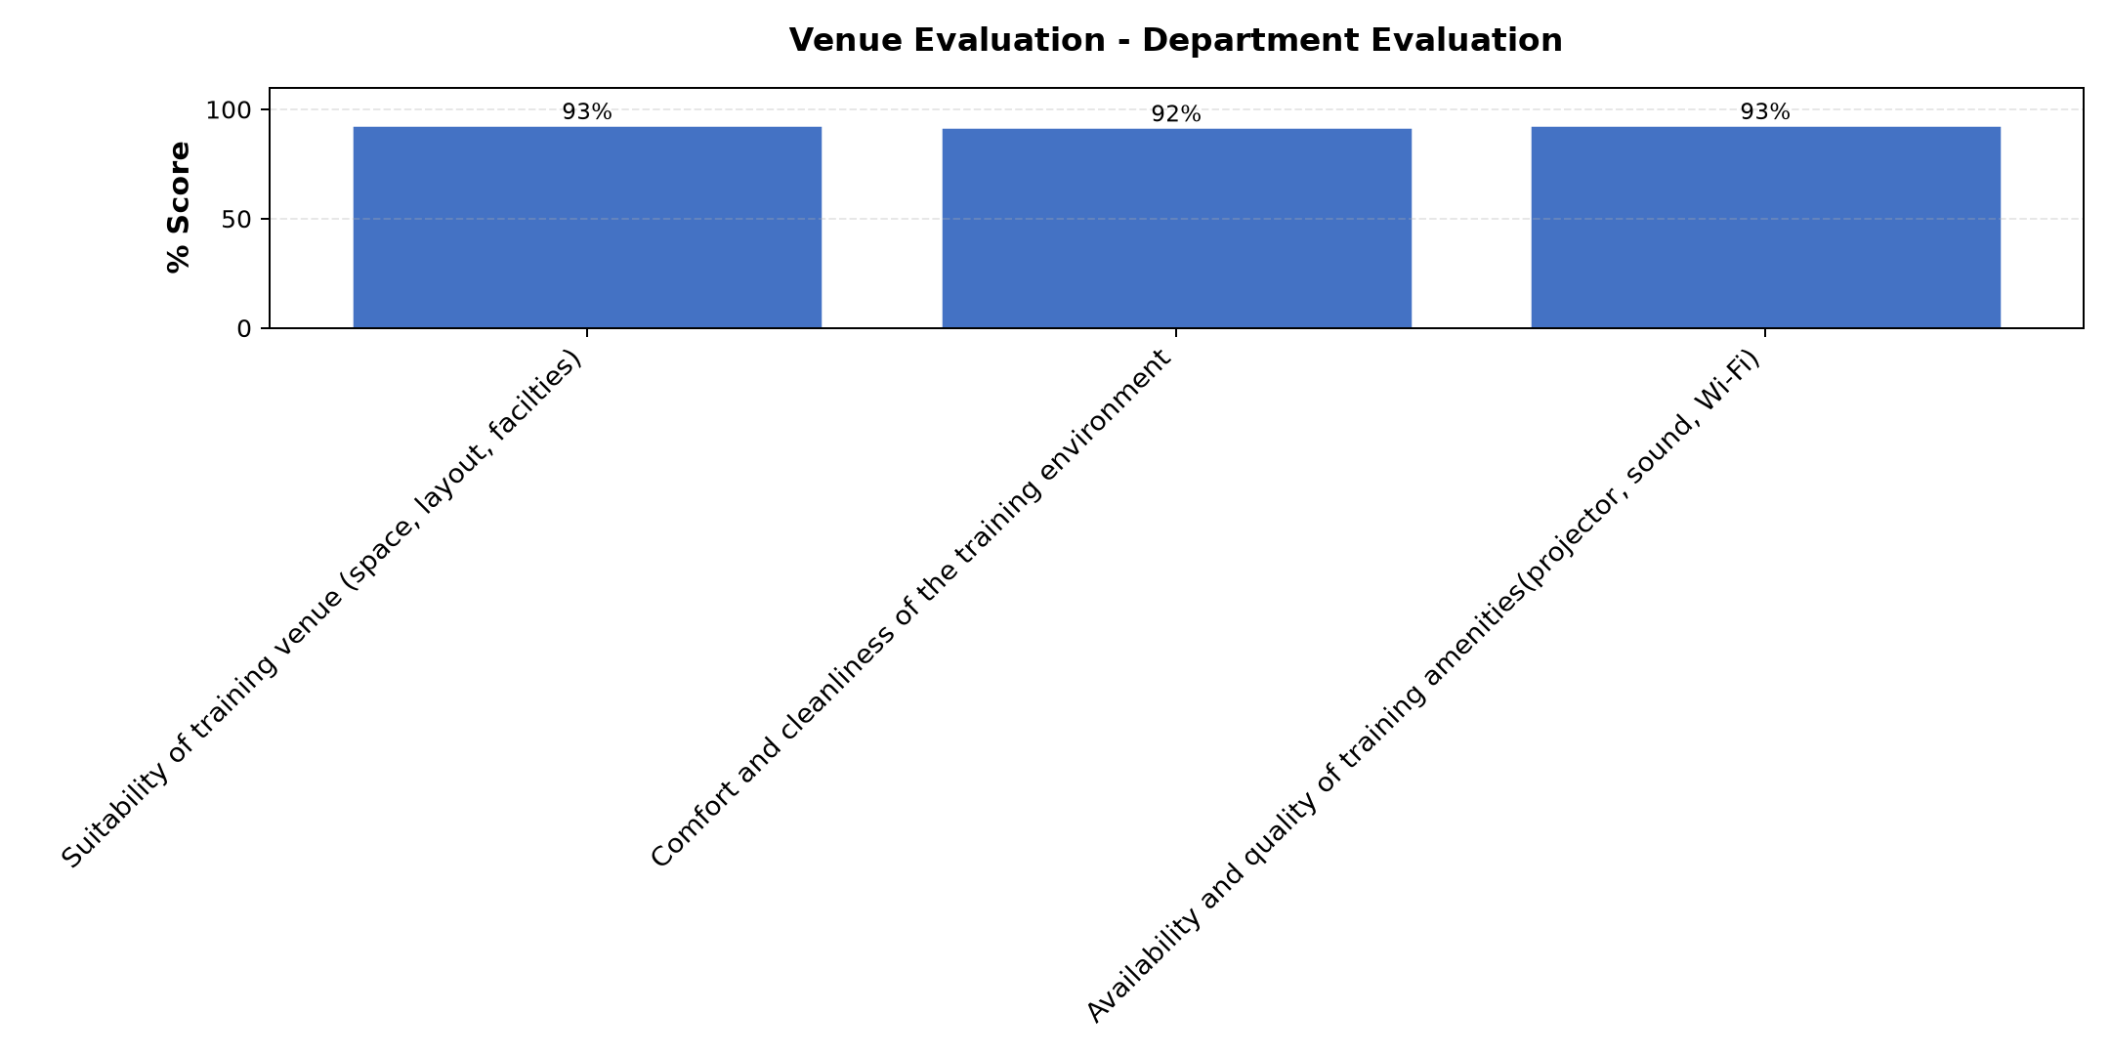

Comments & Feedback
- • May the all Might God Bless you abundantly
- • Asanteni sana viongozinwetu Kwa maandalizi mazuri ,ambayo yametuwezesha kujifunza Kwa vizuri.
- • Thank you for running the group with a great wisdoms
- • Very good
- • Nil
- • Nampongeza sana
- • Mungu amjalie afya
- • Iko vizuri ina hewa na nafasi ya kutosha
- • Asanteni sana mungu wabariki sana
- • Was conductive and enough facilities place for learning
- • Thanks

What attracted you to the programme??

Comments & Feedback
- • Msimamizi mkuu wa mradi
- • How to make school board
- • Uongozi
- • Services and customer care of our leaders and lecturers
- • Positive sharing with others
- • The way facilitators are humble in helping us
- • Teaching methods
- • Namna semina ilivyoandaliwa na ziara ya kwenda kiwanda Cha maji imenipa moyo wa kudhubutu na kutambua Kwamba Kila kitu kinawezekana ukipenda.
- • Program contacting
- • Kitu nilichovutiwa kwenye hii program ni kutuletea walimu wazuri
- • Cooperation, accountability, and collaboration of the team members, commitment and presenters' integrity .
- • Finding the social enterprise
- • Mimi binafsi nimeguswa na topiki ya social Enterprice na Strategick planning pia kutembelea kiwandani
- • How humble and transparent facilitators are.

What topic would you recommend being expanded/improved in this programme’s units?

Comments & Feedback
- • Funding sources
- • Kujali kazi yako ndiyo jina lako
- • Usimanizi kwa mradiwako
- • Kufanya kazi kwatija na kujali
- • Topic zote zimeeleweka
- • Mbinu shirikishi
- • Succession planing
- • Funding sources
- • Operation and efficiency
- • Njia nzuri za kupata fedha za kuendesha miradi tuliyo nayo
- • Government and succession,and operation and Efficiency
- • Topic inayohusu ufanisi katika kazi,it,na governance and succession planning
- • Nil
- • Operation efficient

Which areas in this programme did you find most important to your social enterprise?

Comments & Feedback
- • -ni nzuri sana
- • Ina manufaa kwetu na kwashirika
- • Sehemu zote zimeeleweka
- • Namna ya kusimamia biasharara na kuongoza wale ninaowasimamia
- • Governance and Succession planing
- • Social impact planning
- • Almost all parts are important
- • Government and succession
- • Njia za kutafuta wafadhili na usimamizi nzuri wa miradi tuliyo nayo
- • Financial resources, governance and succession planning and It
- • How to make sustainability of our project
- • IT Technology and Finding resources including Governence and succession planing
- • Kutokana na mafunzo haya yameisaidia kujua ni mbinu gani nitumie ili niweze kufanikiwa zaidi kati kuboresha mradi wangu kwa kutumia mbinu nilizofundishwa
- • All ares are good

Which teaching methods applied in the course did you enjoy/learn from the most?

Comments & Feedback
- • Discussion
- • Discussion methods
- • Msimamizi mkuu wa mradi
- • Ya kutushirikisha kutoa mawazo
- • Njia ya kuuliza maswali
- • Uongozi na usimamizi mzuri wa rasilimali watu na rasilimali fedha
- • Ni kujifunza kwa matendo
- • Discussion, questions and answers, role play, field trip and interactive lecture.
- • IT technology

